**S3**

* S3 is a global service
* Create a S3 bucket and name should be unique across the AWS
* Allow the public access, to access the website from the internet  
  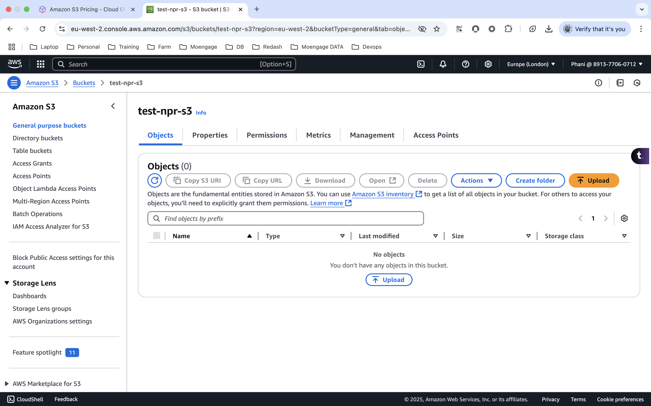
* Upload the files related to the website to the s3 bucket  
   (<https://www.free-css.com/free-css-templates>)  
  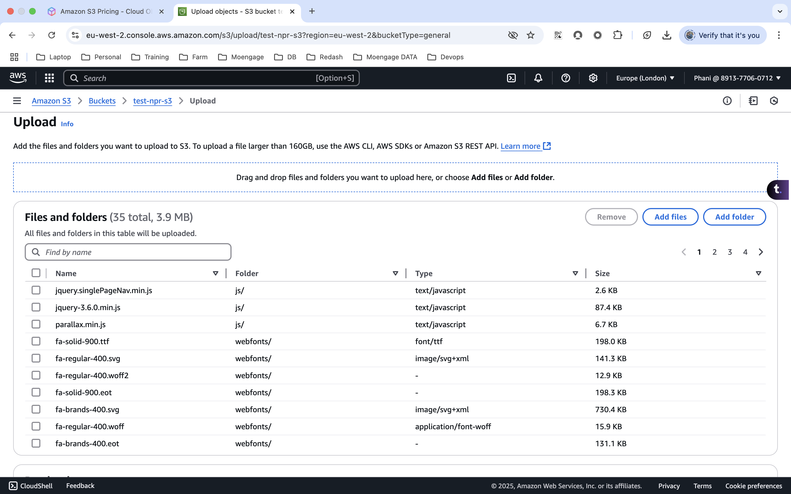  
    
  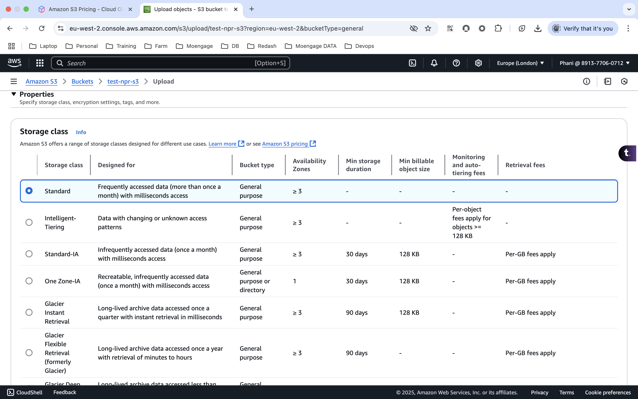  
    
  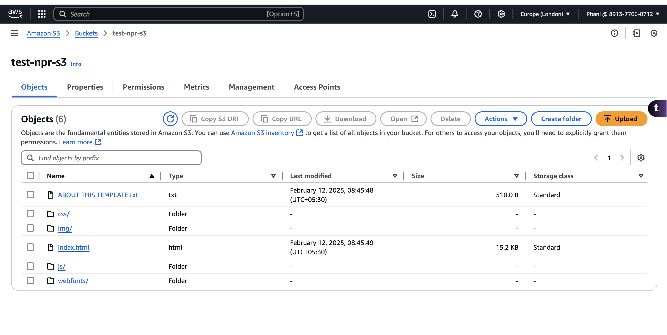
* Now when we try to access this from the internet, it says access denied.
* Also, one object is not able to access another object  
  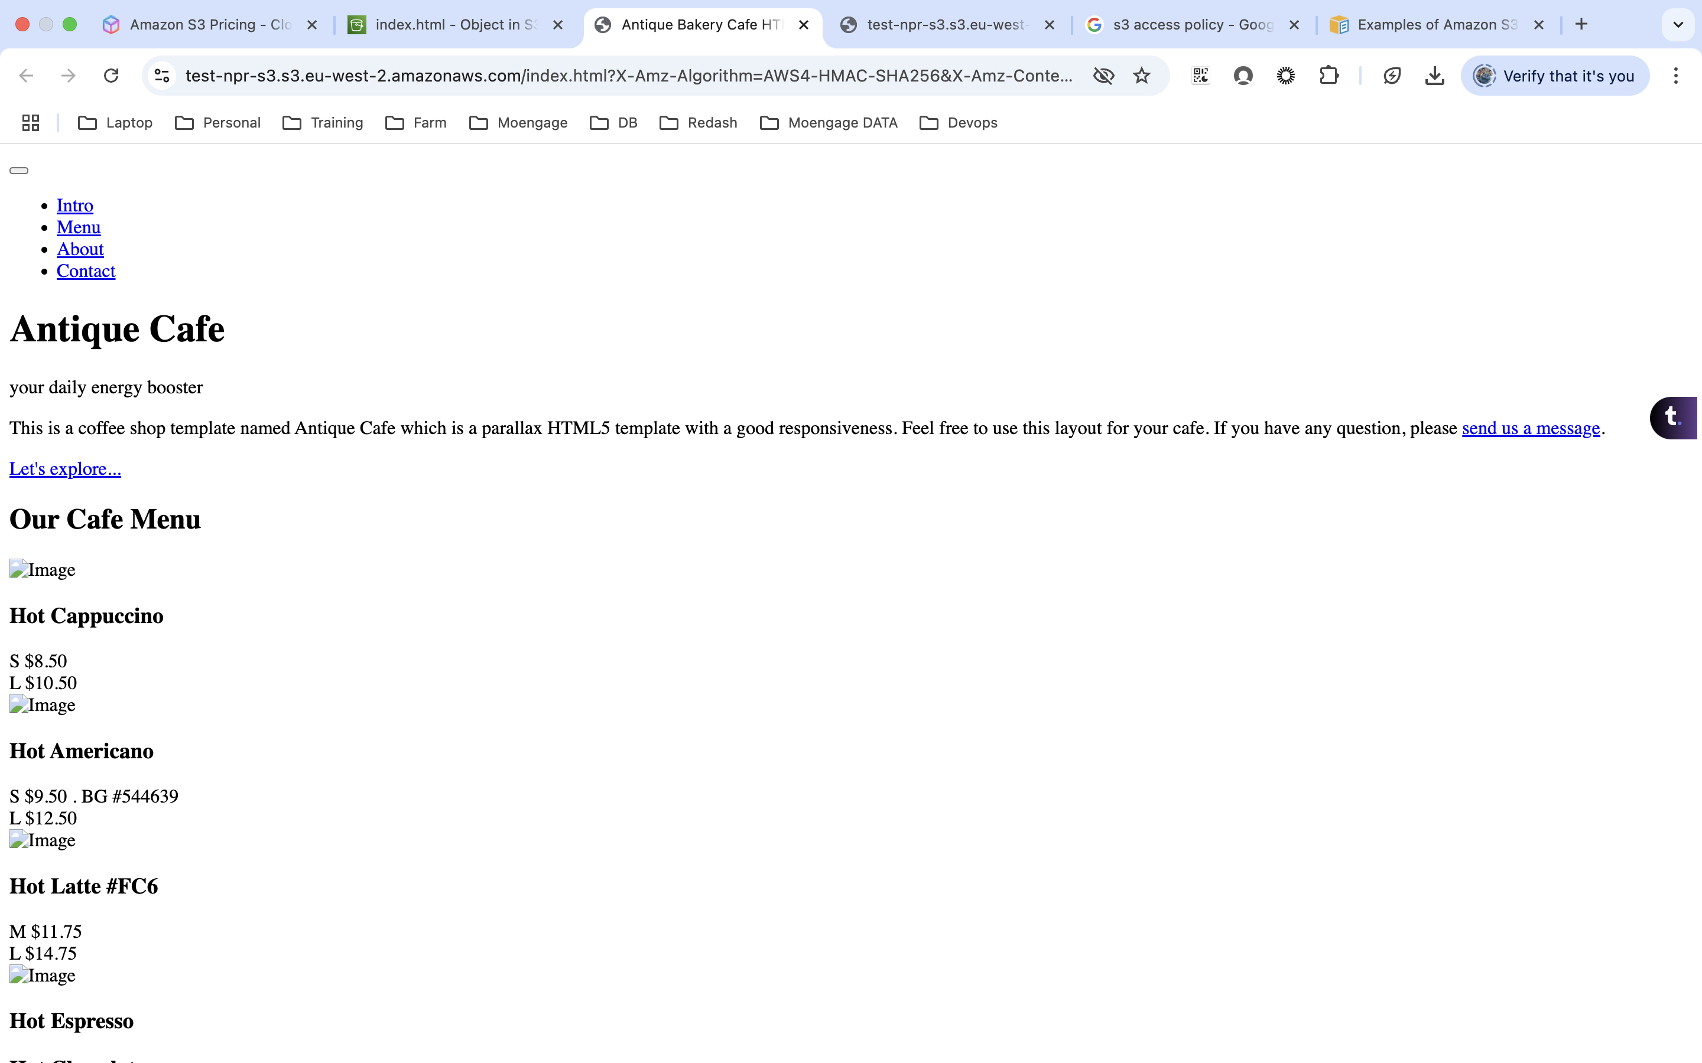
* To overcome this we need to add the policy to the bucket
* Under Permissions of the bucket, we need to edit the policy and add the respective policy.  
  